**Task Analysis**

Analysis and Design of User Interfaces (SEG3125)  
**Project Final Heuristic Report**

Prepared For:  
Professor Fadi Malek

In accordance to the requirements of:

SEG3125 Spring/Summer 2018

Prepared By:

Mahyar Gorji (8135109)

Nicolas Paré (7084451)

Parastoo Saharkhiz (8697886)

University of Ottawa

Faculty of Engineering

July 20, 2018

Summary:

In the body of this report, you will find:

1. Screenshots of all of the main functionality of the webpage *UglierYOU*, designed in accordance to the requirements of the final project of SEG3125-S.
2. A complete heuristic evaluation, along with severity levels and recommended solutions.

Included in this report are screen captures of heuristic violations, as well as the violation category they fall into, alphanumeritized via the same method as the powerpoint slides in class. See below for the complete list discussed in lectures:

H2-1: Visibility of system status

H2-2: Match between system and real world

H2-3: User control and freedom

H2-4: Consistency & standards

H2-5: Error prevention

H2-6: Recognition rather than recall

H2-7: Flexibility and efficiency of use

H2-8: Aesthetic and minimalist design

H2-9: Help users recognize, diagnose, and recover from errors

H2-10: Help and documentation

The goal, while wishing to remain precise, is to showcase some major violations and some more minor violations, as will be shown with each violation’s severity rating. In the interest of time and academic commitments, our group will **not** showcase each and every violation that is possible to be found on UglierYOU.

Screenshots

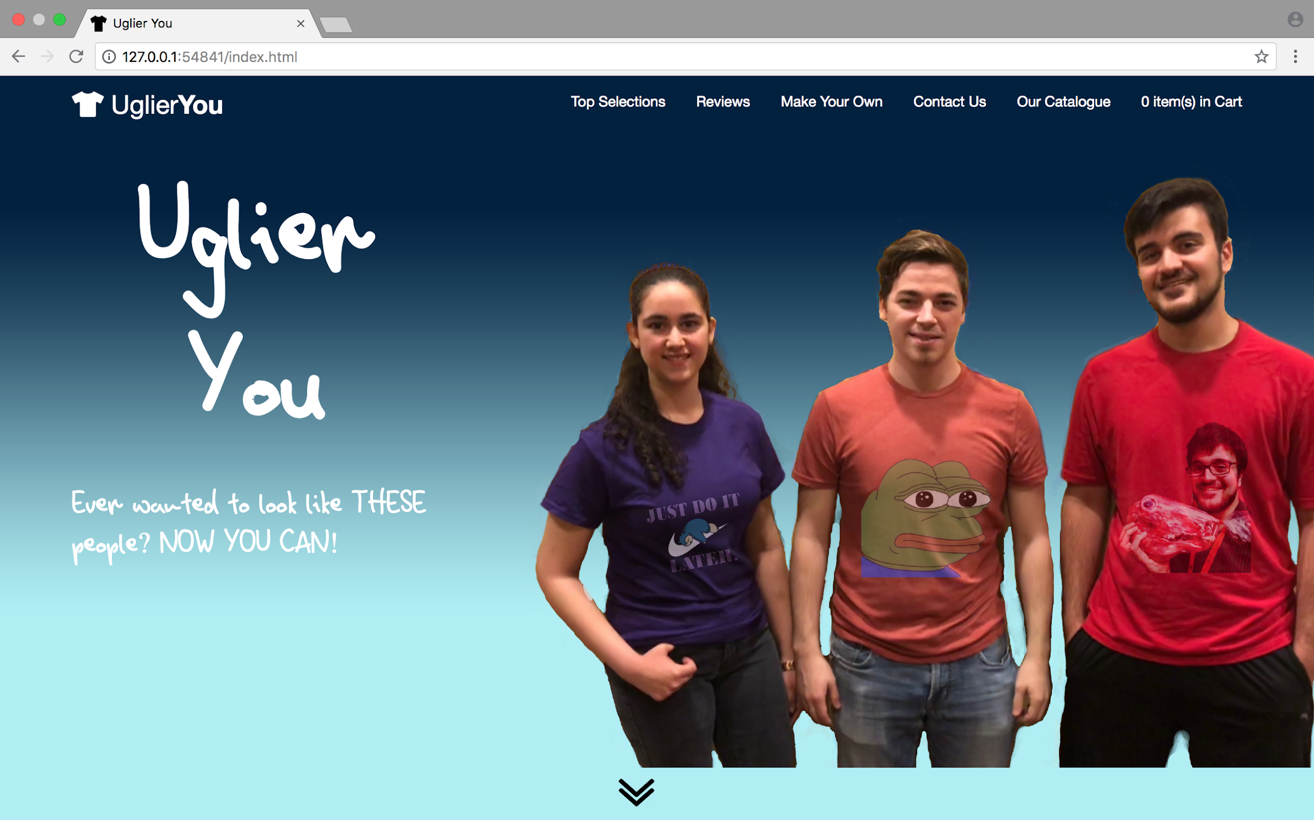

Figure 1: Landing Page Jumbotron and Navbar

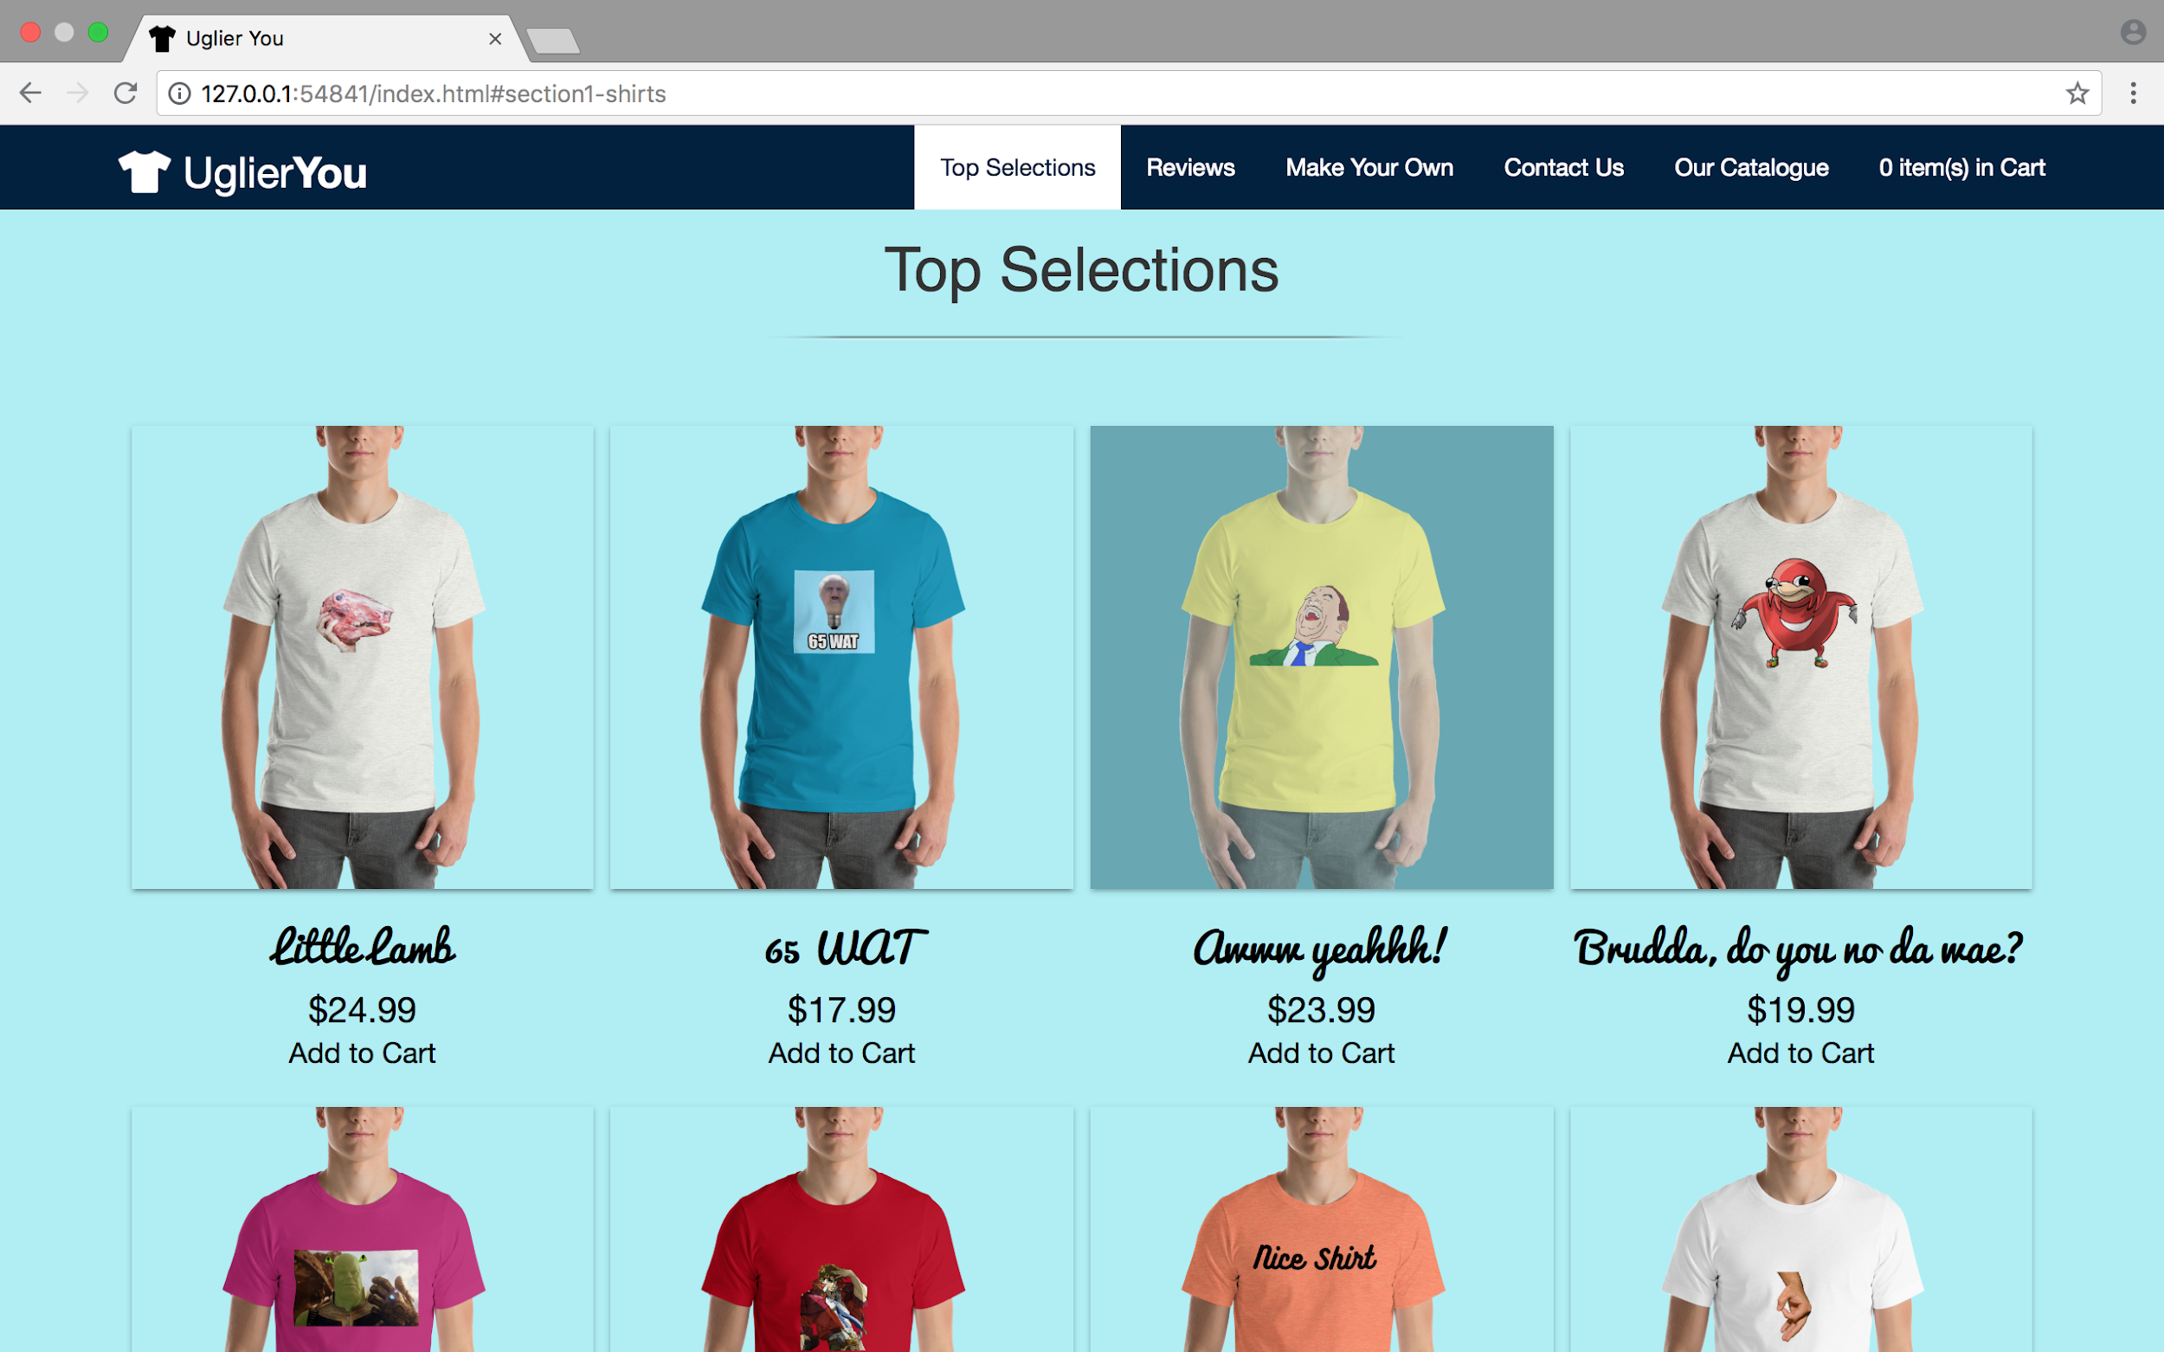

Figure 2: Top Selections of Shirts, Active Navbar.

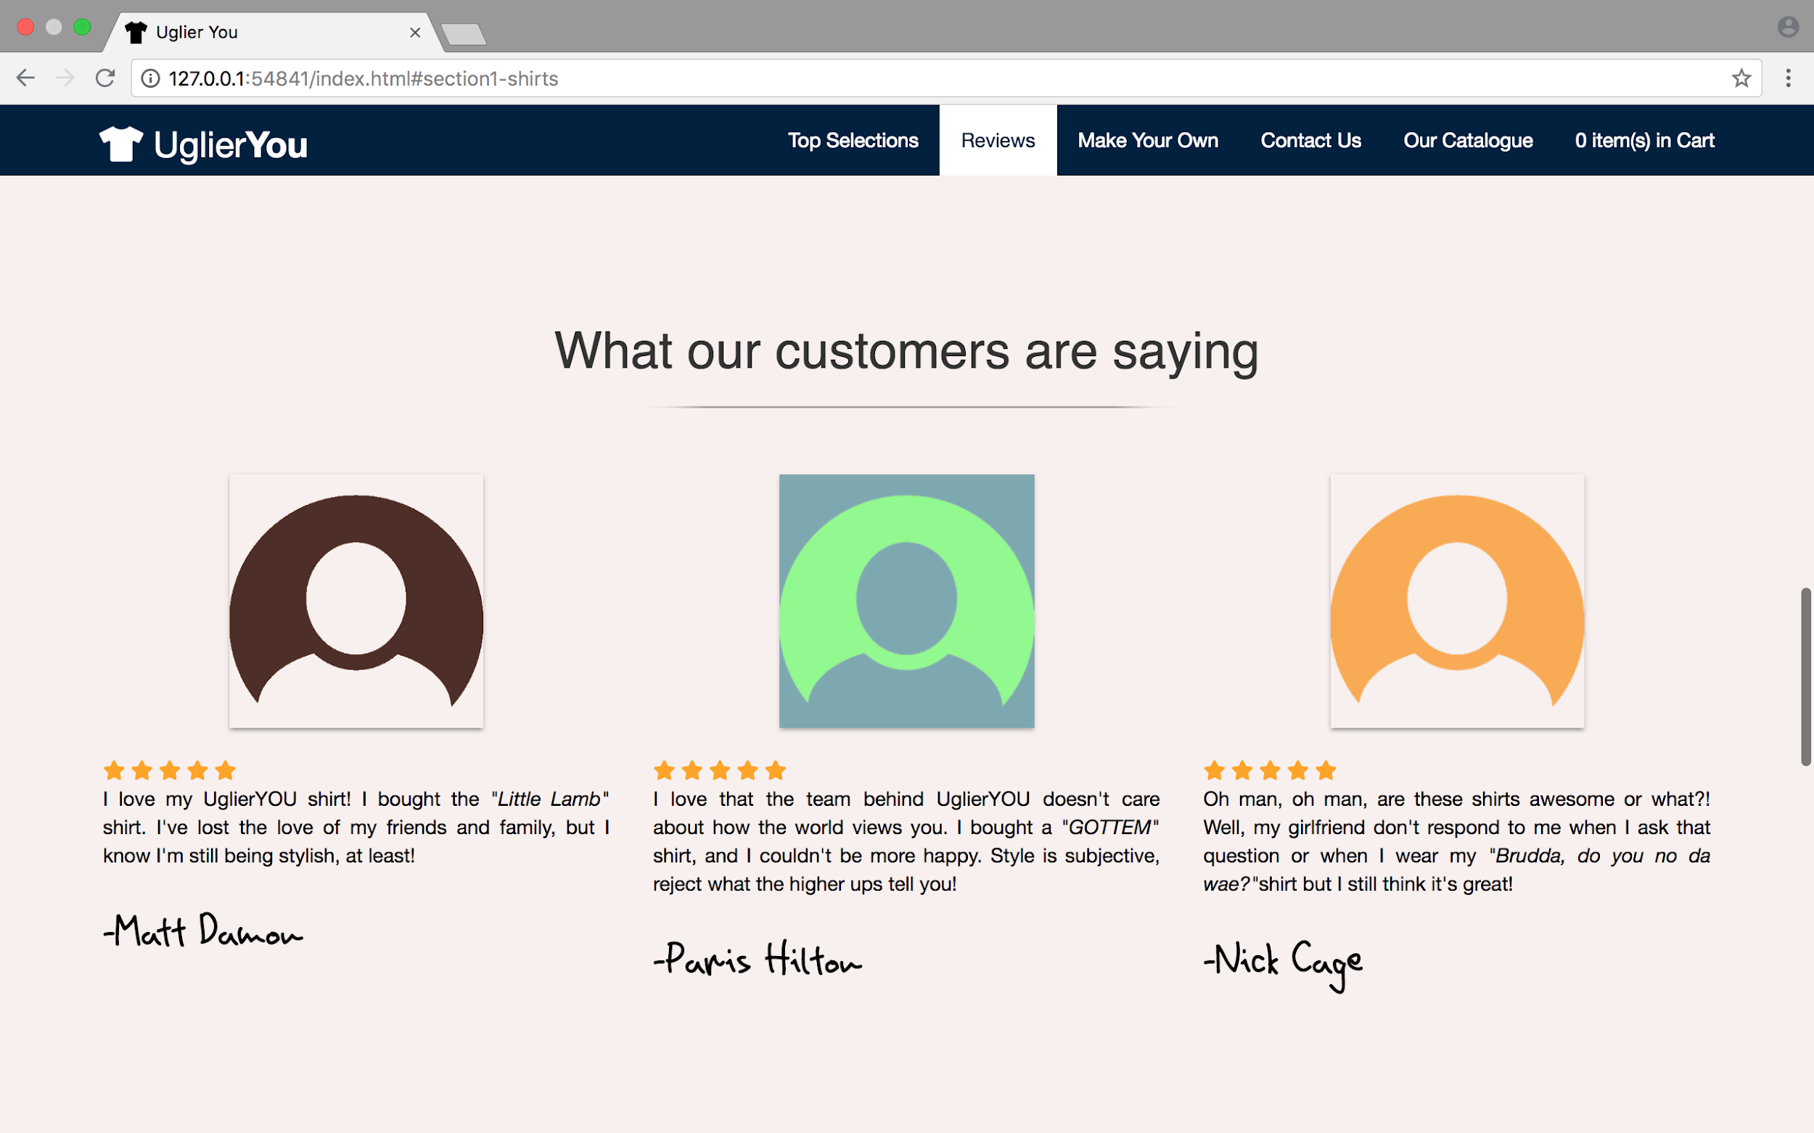

Figure 3: Reviews

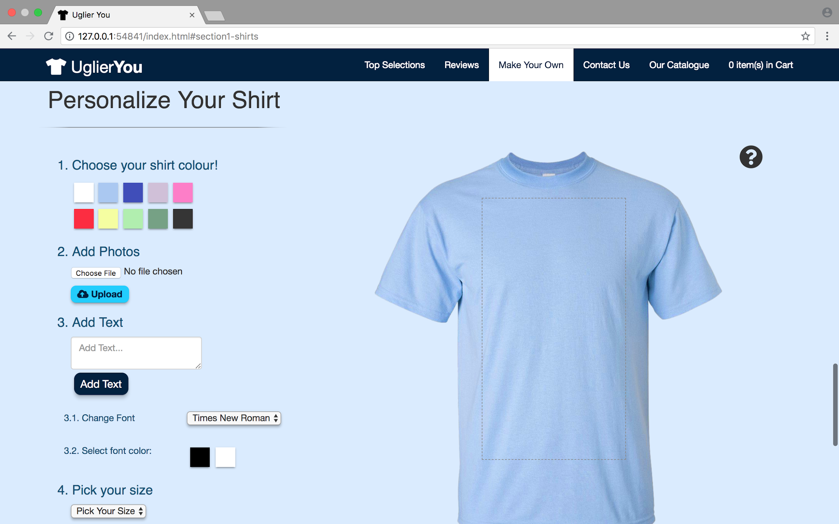

Figure 4: Personalize T-Shirt

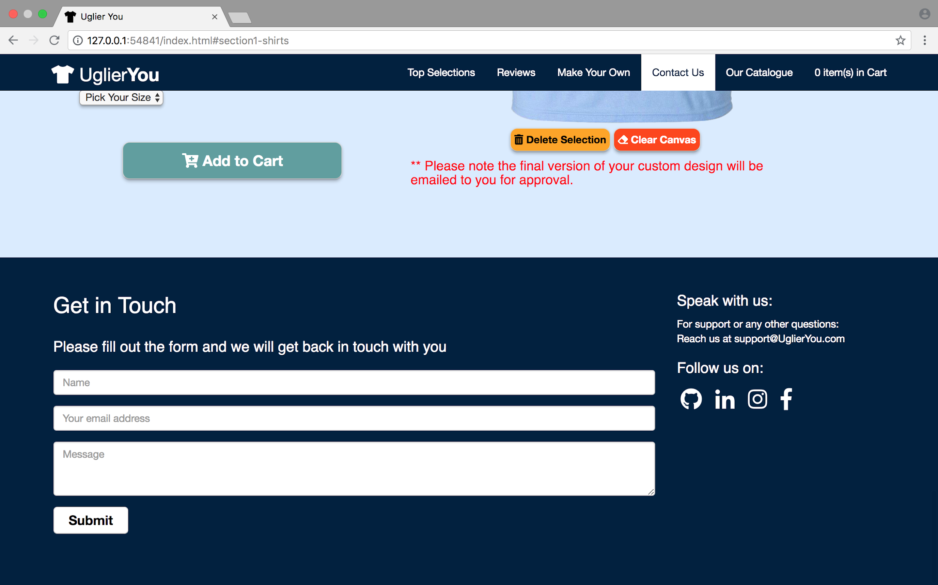

Figure 5: Feedback Forms, Links to Product Pages.

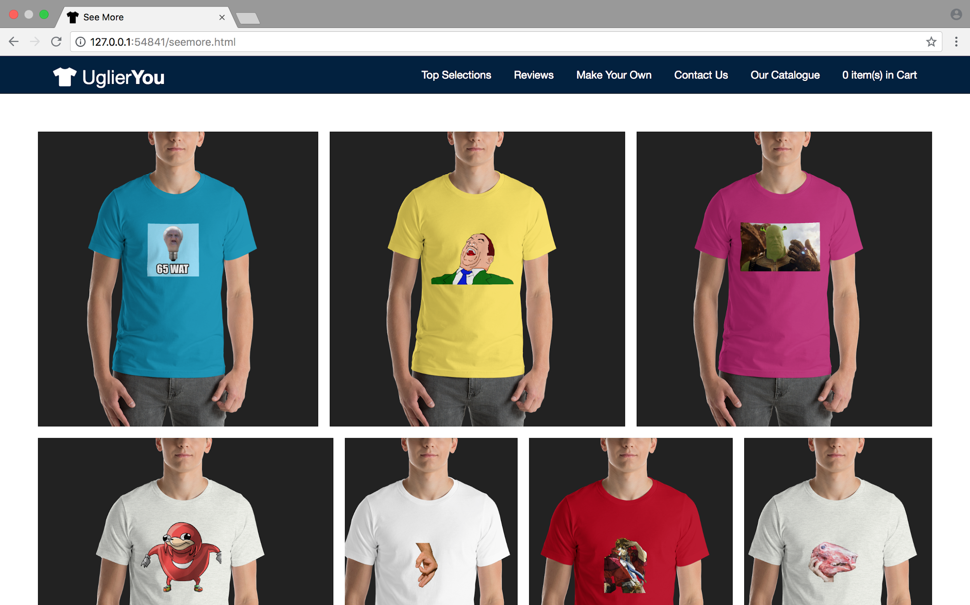

Figure 6: Freewall.js resizable catalogue

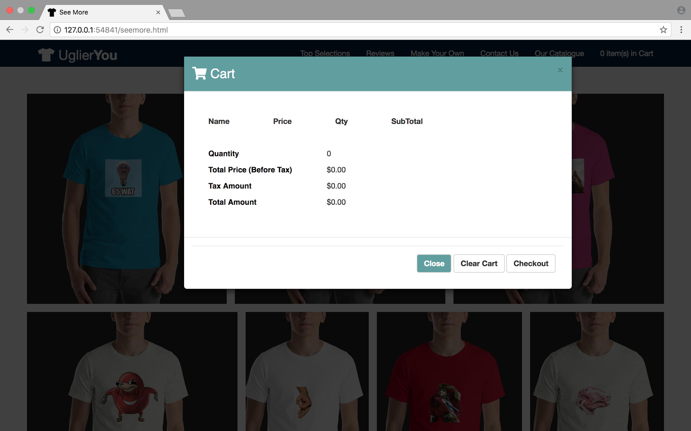

Figure 7: Cart, complete with paypal checkout functionality.

Heuristics:

It should be noted that while the following heuristic violations were present in the final product for UglierYOU, the quantity of violations is low. This is because the team kept the list of potential violations in mind when creating the site, allowing class knowledge and material to positively influence the final product.

Violations:

1. H2-1: No easily-visible notification that an item has been added to the cart.

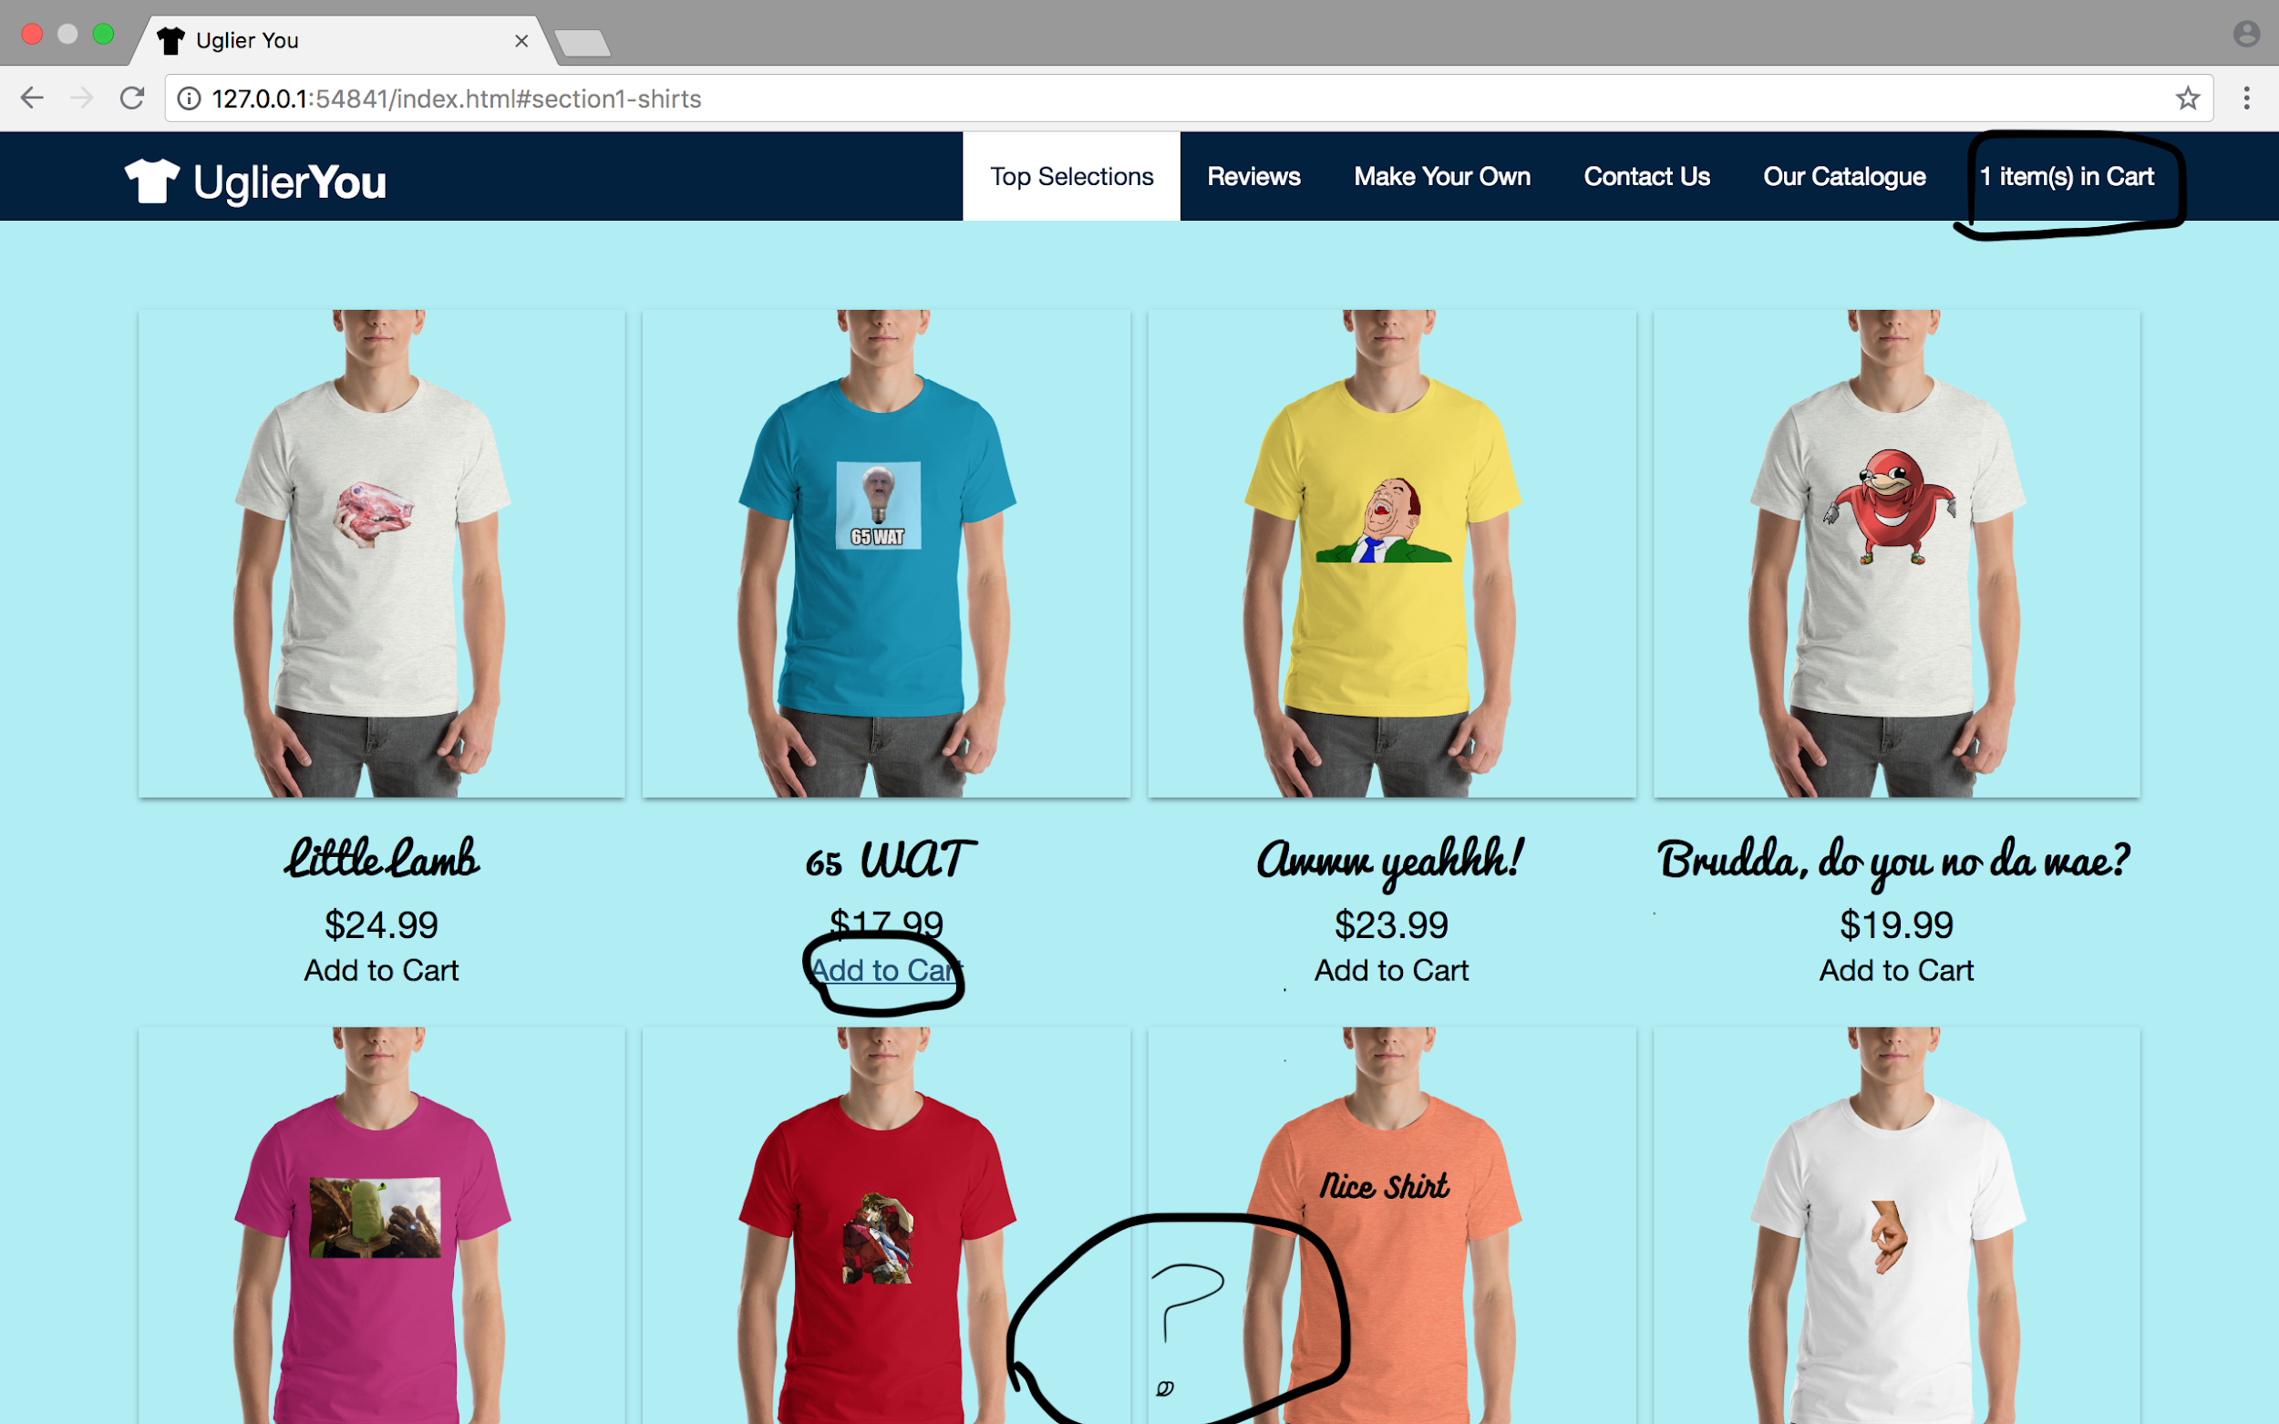

As can be noticed, clicking the “add” to cart link quietly increments the cart quantity, while giving the user no indication of this, unless they were to look at the top right of the screen.

Severity Rating: 7/10.

This is higher in severity due to the amount of unnecessary and avoidable mistakes that the user can experience as a result. Perhaps the user will think that the “Add to Cart” button did not work the first time, add another item to the cart, and mistakenly checkout with double the quantity of shirts they originally wanted. This is a problem that is easily solved early, but can leave a bad impression on the user.

Solution:

In the portion of the screen with a question mark, implement a toast/snackbar notification on every “Add to Cart” button, so that the user will obtain feedback about the decision they’ve just made, and will naturally be prompted to look towards the cart.

1. H2-4: Potentially confusing hover over product photo

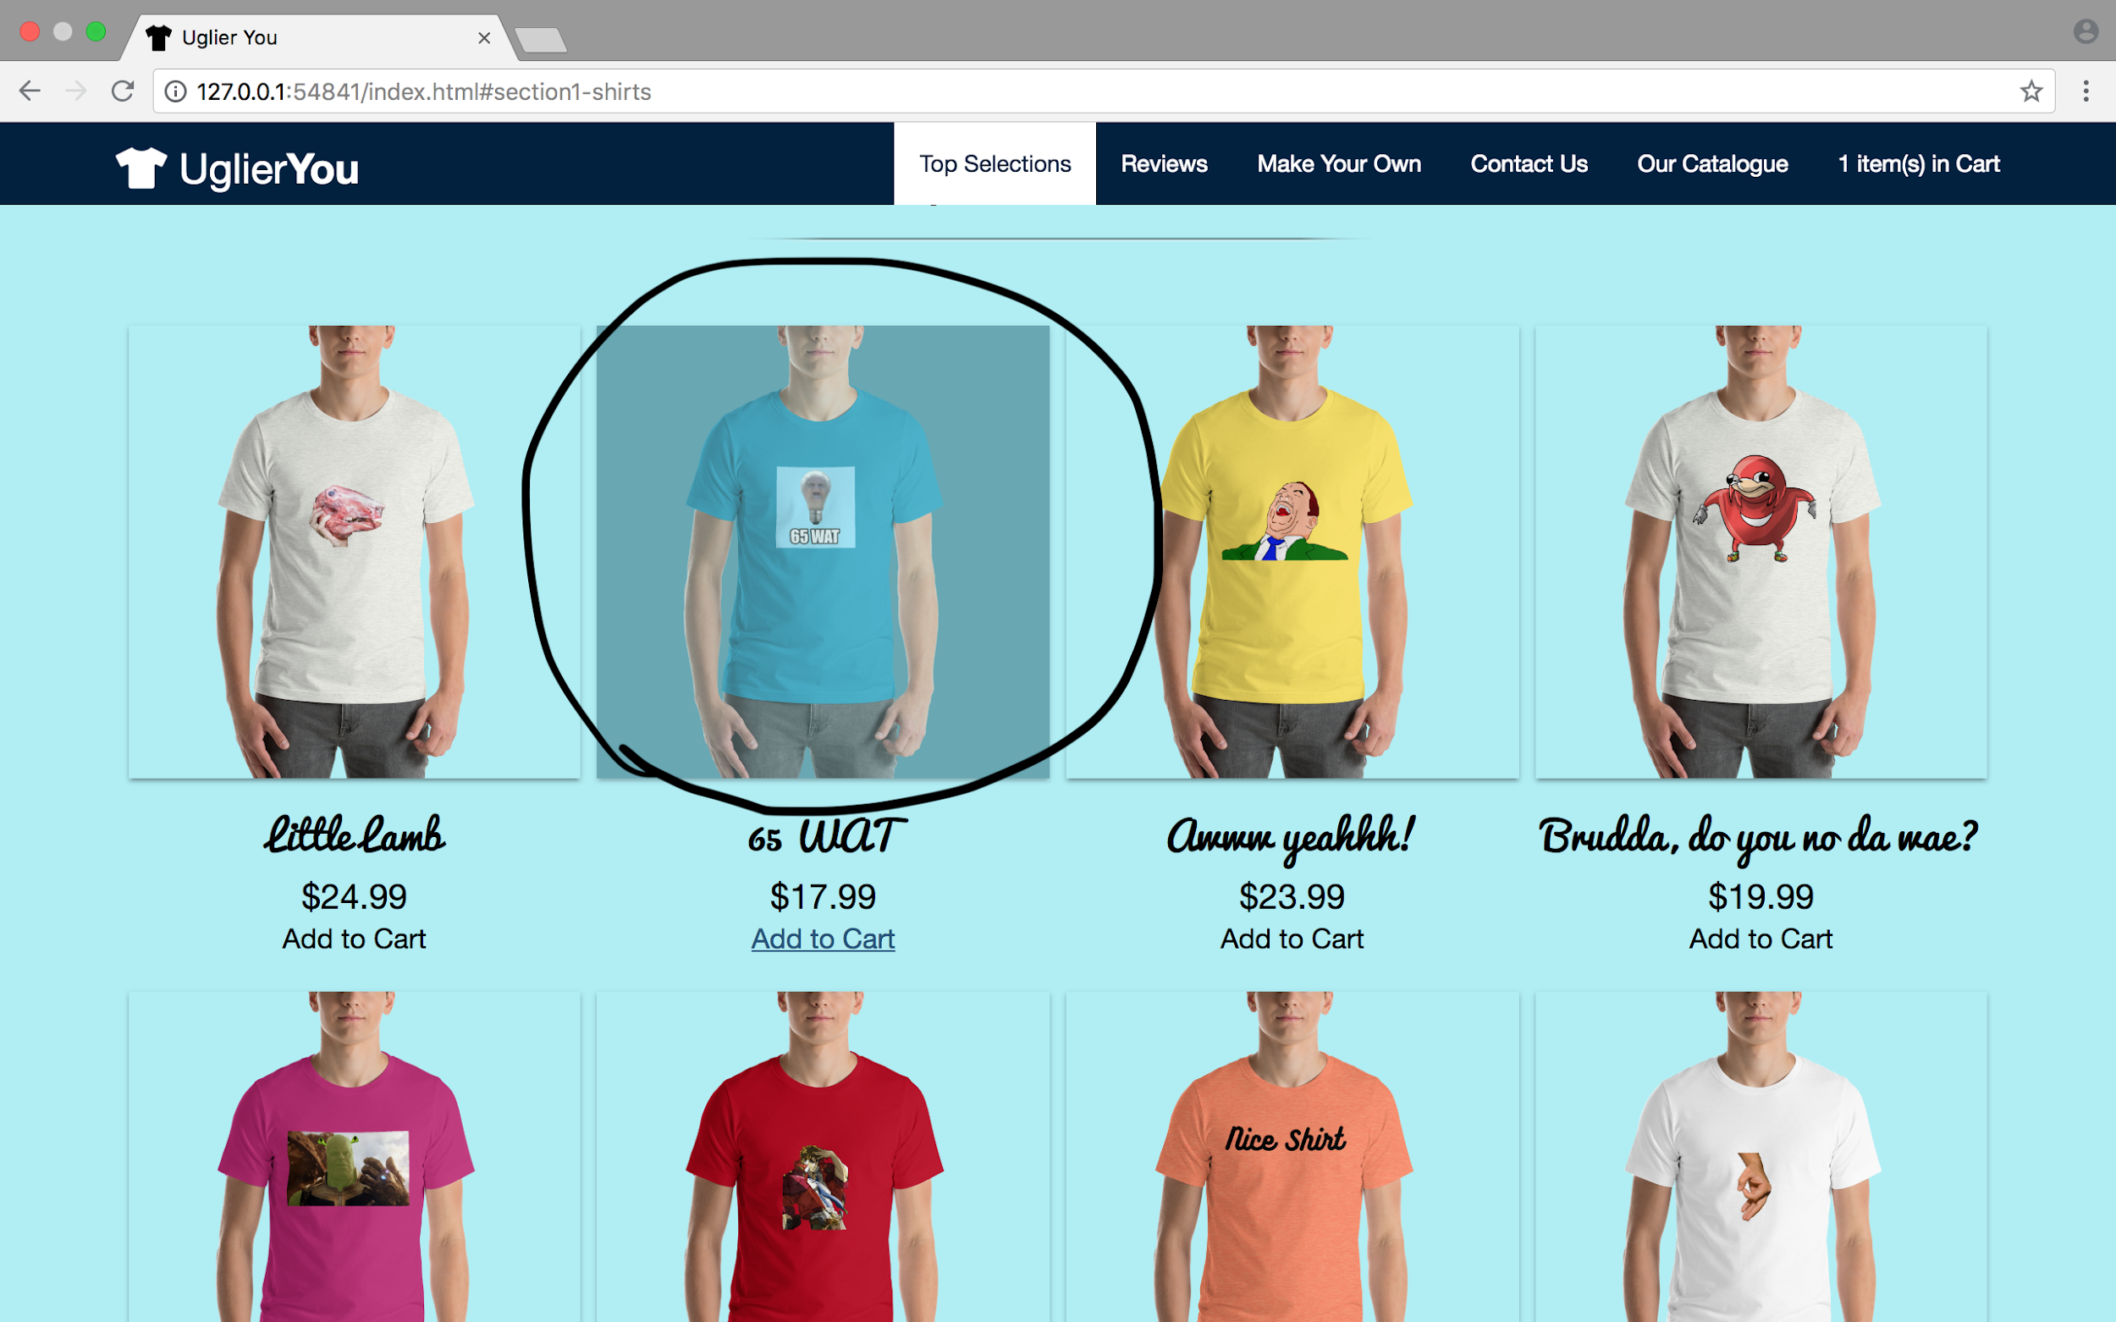

In this photo, the cursor is hovered over the “65 WAT” shirt option, but the image does changes opacity, producing feedback that would naturally lead the user to believe they are clicking a selection.

Severity Rating: 2/10

This issue, while potentially confusing to the user, does not enact any catastrophic failures or incorrect purchase prices, which would deeply and negatively affect the user’s opinion of the website.

Solution:

Either link the shirt to a display page, which would have to be created, and implement the appropriate cursor type OR remove the hover opacity effect and leave the images to be static.

1. H2-4: Awkward positioning of navbar “catalogue” option  
   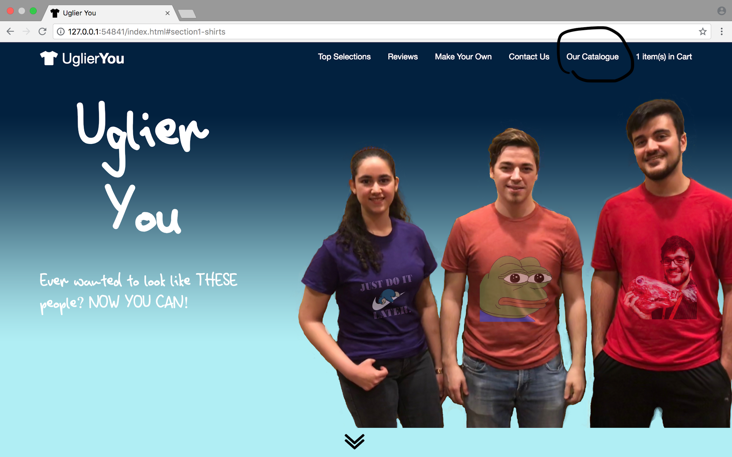  
   In this photo, the user may notice that the “Our Catalogue” selection of the navigation bar is beside the “Contact Us” and not the “Top Selections” portion. This provides a sense of awkwardness, where the user might believe that the option is misplaced. This is made worse when noticing that this navbar option is not in chronological order on the page, and is instead a separate page altogether.

Severity Rating: 3/10

This issue, while potentially confusing to the user, does not enact any catastrophic failures or incorrect purchase prices, which would deeply and negatively affect the user’s opinion of the website. The worst that could happen is that the user may think that the design choice is poor.

Solution:

Move the “Our Catalogue” navbar link to the left of the “Top Selections” link, in order to preserve the navbar’s chronological order when moving through the different sections of the site.

Conclusion:

Apart from the mentioned heuristics that UglierYou violates, it does follow a good number of heuristics that offers users with a good experience while exploring the website. For example the chevron that appears below the jumbotron signals users to scroll down and when clicked, it directs them to view the shirts the website advertises. On the customize section, there is a ‘Help’ button that provides some documentation on how one can customize a shirt. In that section, if a user clicks the ‘Upload’ button or ‘Add Text’ button, but has not selected any files or not provided any text will receive a warning message to help them get the task done as wished. If someone clicks the ‘Clear Canvas’ button, they will be asked to confirm their selection to avoid user errors.   
  
 In conclusion, our team worked really hard to create a UI that follows the heuristics as closely as possible and since this phase of the project asked to focus on the heuristic violations, we decided to look back on our design and do a full analysis of the heuristics and point out the next steps to even more improving our website.